Lab 3: Bootstrap
Date: 24/01/2026

Q1. Design the student bio-data form using button, label, textbox, radio button, table and checkbox.

Code:
<!DOCTYPE html>
<html lang="en">
<head>
<title>Student Bio-Data Form</title>
<meta charset="utf-8">
<meta name="viewport" content="width=device-width, initial-scale=1">
<link href="https://cdn.jsdelivr.net/npm/bootstrap@5.3.8/dist/css/bootstrap.min.css" rel="stylesheet">
<script src="https://cdn.jsdelivr.net/npm/bootstrap@5.3.8/dist/js/bootstrap.bundle.min.js"></script>
</head>
<body class="bg-light">
<div class="container mt-5">
<div class="card shadow-lg">
<div class="card-header bg-primary text-white">
<h2 class="mb-0">Student Bio-Data Form</h2>
</div>
<div class="card-body">
<form>
<h4 class="mb-3">Personal Information</h4>
<div class="row mb-3">
<div class="col-md-6">
<label for="studentName" class="form-label">Full Name</label>
<input type="text" class="form-control" id="studentName" placeholder="Enter your full name" required>
<div class="invalid-feedback">Name is required.</div>
</div>
<div class="col-md-6">
<label for="studentEmail" class="form-label">Email</label>
<input type="email" class="form-control" id="studentEmail" placeholder="Enter your email" required>
<div class="invalid-feedback">Please enter a valid email address.</div>
</div>
</div>
<div class="row mb-3">
<div class="col-md-6">
<label for="studentPhone" class="form-label">Phone Number</label>
<input type="tel" class="form-control" id="studentPhone" placeholder="Enter your phone number" pattern="[0-9]+" required>
<div class="invalid-feedback">Please enter digits only (0–9).</div>
</div>
<div class="col-md-6">
<label for="studentDOB" class="form-label">Date of Birth</label>
<input type="date" class="form-control" id="studentDOB" required>
<div class="invalid-feedback">Date of birth is required.</div>
</div>
</div>
<div class="mb-3">
<label class="form-label">Gender</label><br>
<div class="form-check form-check-inline">
<input class="form-check-input" type="radio" name="gender" id="male" value="Male" required>
<label class="form-check-label" for="male">Male</label>
</div>
<div class="form-check form-check-inline">
<input class="form-check-input" type="radio" name="gender" id="female" value="Female">
<label class="form-check-label" for="female">Female</label>
</div>
<div class="form-check form-check-inline">
<input class="form-check-input" type="radio" name="gender" id="other" value="Other">
<label class="form-check-label" for="other">Other</label>
</div>
<div class="invalid-feedback">Please select a gender.</div>
</div>
<h4 class="mb-3">Academic Information</h4>
<div class="row mb-3">
<div class="col-md-6">
<label for="studentCourse" class="form-label">Course</label>
<input type="text" class="form-control" id="studentCourse" placeholder="e.g. B.Sc Computer Science" required>
<div class="invalid-feedback">Course is required.</div>
</div>
<div class="col-md-6">
<label for="studentYear" class="form-label">Year of Study</label>
<select class="form-select" id="studentYear" required>
<option selected disabled value="">Choose...</option>
<option>1st Year</option>
<option>2nd Year</option>
<option>3rd Year</option>
<option>Final Year</option>
</select>
<div class="invalid-feedback">Please select your year of study.</div>
</div>
<div class="row mt-3">
<div class="col-md-6">
<label for="studentMentor" class="form-label">Mentor Name</label>
<input type="text" class="form-control" id="studentMentor" placeholder="Enter name of mentor" required>
<div class="invalid-feedback">Mentor is required.</div>
</div>
</div>
</div>
<div class="mt-4">
<button type="submit" class="btn btn-success">Submit</button>
<button type="reset" class="btn btn-danger">Reset</button>
</div>
</form>
</div>
</div>
</div>
</body>
</html>

Output:
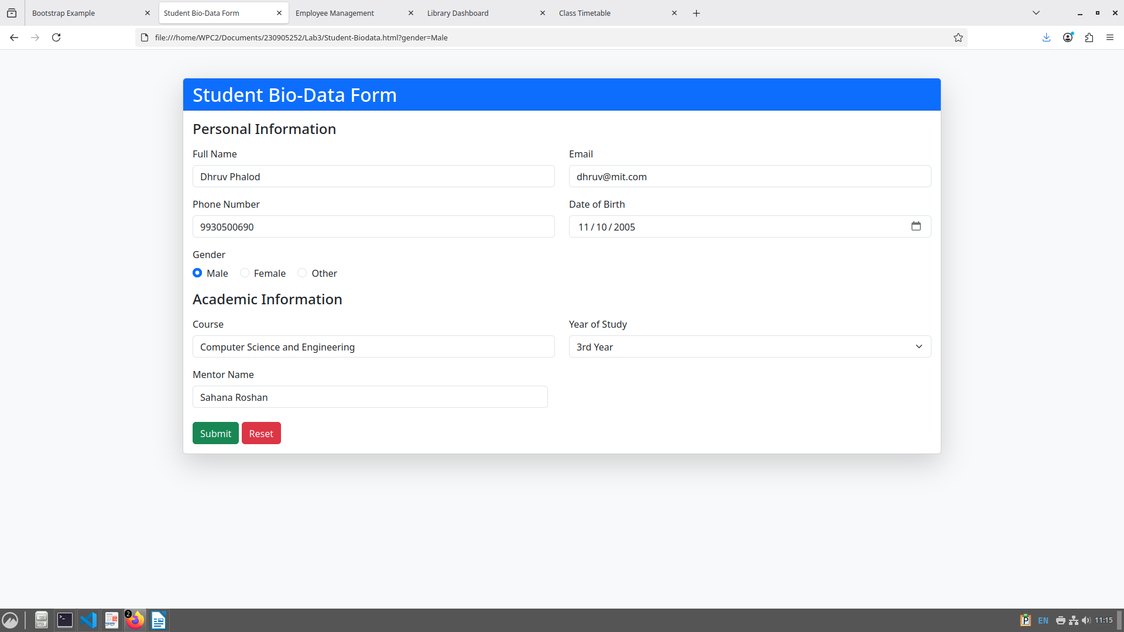

2. Design a web page which shows the database-oriented CRUD operation. Consider Employee data.

Code:
<!DOCTYPE html>
<html lang="en">
<head>
<title>Employee Management</title>
<meta charset="utf-8">
<meta name="viewport" content="width=device-width, initial-scale=1">
<link href="https://cdn.jsdelivr.net/npm/bootstrap/dist/css/bootstrap.min.css" rel="stylesheet">
<script src="https://cdn.jsdelivr.net/npm/bootstrap/dist/js/bootstrap.bundle.min.js"></script>
</head>
<body class="bg-light">
<div class="container mt-5">
<div class="card shadow-lg">
<div class="card-header bg-primary text-white d-flex justify-content-between align-items-center">
<h2 class="mb-0">Employee Management</h2>
<button class="btn btn-success" onclick="openModal('add')">+ Add Employee</button>
</div>
<div class="card-body">
<table class="table table-hover table-bordered" id="employeeTable">
<thead class="table-dark">
<tr>
<th>ID</th>
<th>Name</th>
<th>Email</th>
<th>Department</th>
<th>Salary</th>
<th>Actions</th>
</tr>
</thead>
<tbody></tbody>
</table>
</div>
</div>
</div>

<div class="modal fade" id="employeeModal" tabindex="-1" aria-hidden="true">
<div class="modal-dialog">
<form class="modal-content" id="employeeForm">
<div class="modal-header">
<h5 class="modal-title" id="modalTitle">Add Employee</h5>
<button type="button" class="btn-close" data-bs-dismiss="modal"></button>
</div>
<div class="modal-body">
<input type="hidden" id="editIndex">
<div class="mb-3">
<label class="form-label">ID</label>
<input type="number" class="form-control" id="empId" required>
</div>
<div class="mb-3">
<label class="form-label">Name</label>
<input type="text" class="form-control" id="empName" required>
</div>
<div class="mb-3">
<label class="form-label">Email</label>
<input type="email" class="form-control" id="empEmail" required>
</div>
<div class="mb-3">
<label class="form-label">Department</label>
<input type="text" class="form-control" id="empDept" required>
</div>
<div class="mb-3">
<label class="form-label">Salary</label>
<input type="number" class="form-control" id="empSalary" required>
</div>
</div>
<div class="modal-footer">
<button type="submit" class="btn btn-primary" id="modalActionBtn">Save</button>
<button type="button" class="btn btn-secondary" data-bs-dismiss="modal">Cancel</button>
</div>
</form>
</div>
</div>

<script>
let employees = [
{ id: 101, name: "John Doe", email: "john@example.com", dept: "HR", salary: 45000 },
{ id: 102, name: "Mary Smith", email: "mary@example.com", dept: "Finance", salary: 55000 }
];

function renderTable() {
const tbody = document.querySelector("#employeeTable tbody");
tbody.innerHTML = "";
employees.forEach((emp, index) => {
tbody.insertAdjacentHTML("beforeend", `
<tr>
<td>${emp.id}</td>
<td>${emp.name}</td>
<td>${emp.email}</td>
<td>${emp.dept}</td>
<td>${emp.salary}</td>
<td>
<button class="btn btn-warning btn-sm" onclick="openModal('edit', ${index})">Edit</button>
<button class="btn btn-danger btn-sm" onclick="deleteEmployee(${index})">Delete</button>
</td>
</tr>
`);
});
}

function openModal(mode, index = null) {
const modalTitle = document.getElementById("modalTitle");
const modalActionBtn = document.getElementById("modalActionBtn");
const form = document.getElementById("employeeForm");

if (mode === "add") {
modalTitle.textContent = "Add Employee";
modalActionBtn.textContent = "Save";
form.reset();
document.getElementById("editIndex").value = "";
} else {
modalTitle.textContent = "Edit Employee";
modalActionBtn.textContent = "Update";
const emp = employees[index];
document.getElementById("empId").value = emp.id;
document.getElementById("empName").value = emp.name;
document.getElementById("empEmail").value = emp.email;
document.getElementById("empDept").value = emp.dept;
document.getElementById("empSalary").value = emp.salary;
document.getElementById("editIndex").value = index;
}

new bootstrap.Modal(document.getElementById("employeeModal")).show();
}

document.getElementById("employeeForm").addEventListener("submit", function(e) {
e.preventDefault();
const index = document.getElementById("editIndex").value;
const empData = {
id: parseInt(document.getElementById("empId").value),
name: document.getElementById("empName").value,
email: document.getElementById("empEmail").value,
dept: document.getElementById("empDept").value,
salary: parseFloat(document.getElementById("empSalary").value)
};

if (index === "") {
employees.push(empData);
} else {
employees[index] = empData;
}

renderTable();
bootstrap.Modal.getInstance(document.getElementById("employeeModal")).hide();
});

function deleteEmployee(index) {
employees.splice(index, 1);
renderTable();
}

renderTable();
</script>
</body>
</html>

Output:
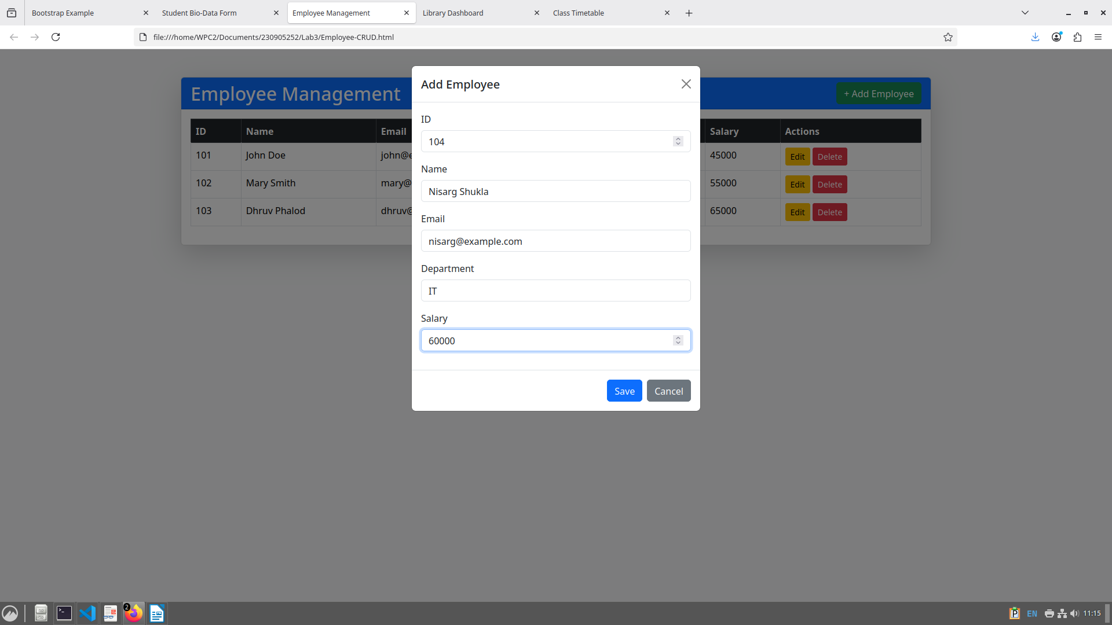
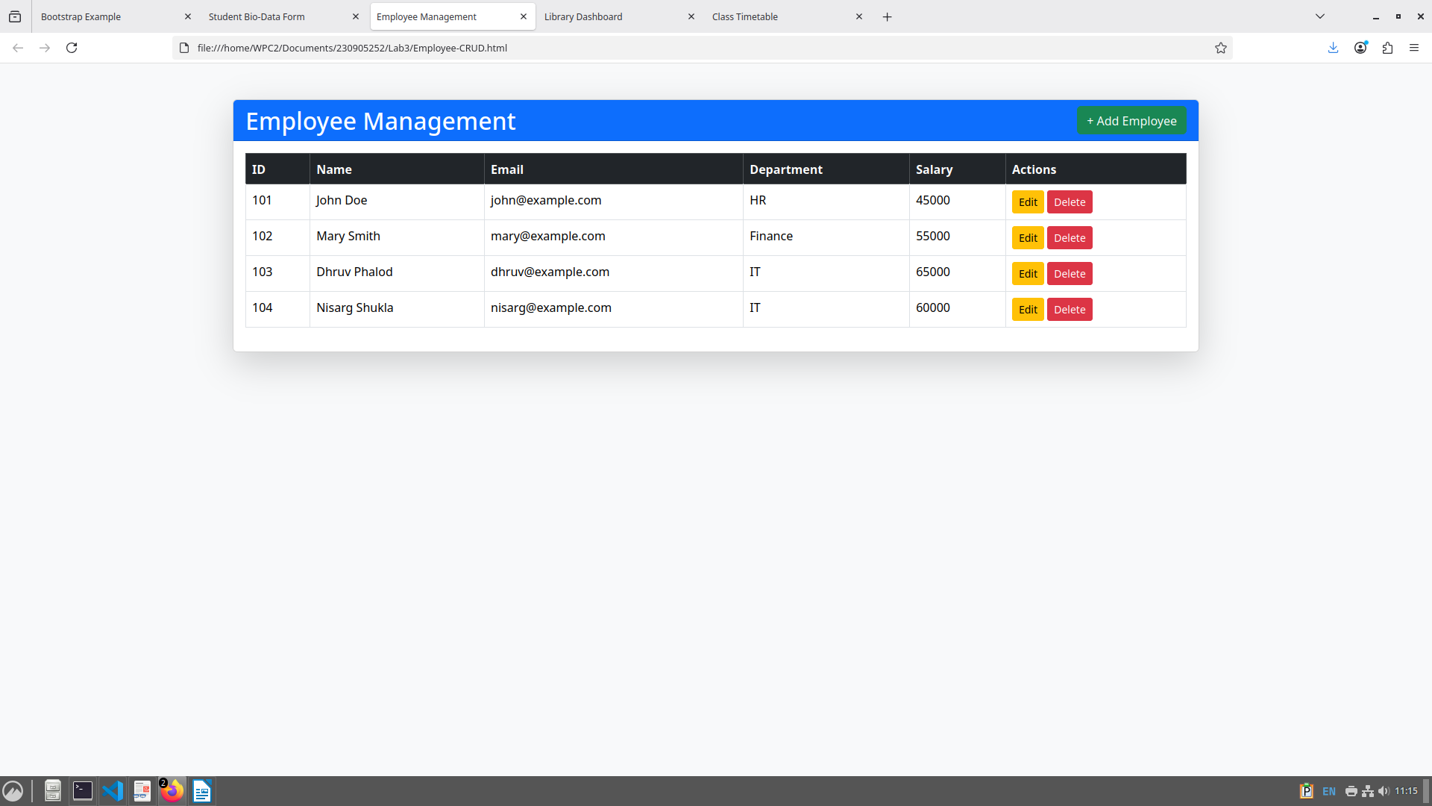
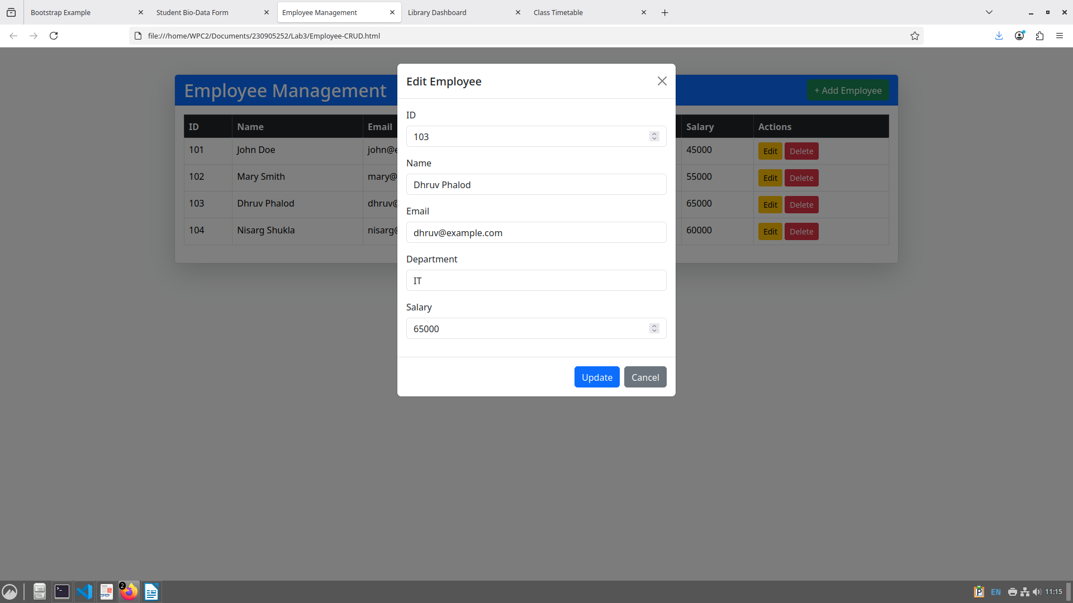

3. Create a web page using bootstrap as mentioned. Divide the page into 2 parts top and bottom, then divide the bottom into 3 parts and design each top and bottom part using different input groups, input, badges, buttons and button groups. Make the design more attractive.

Code:
<!DOCTYPE html>
<html lang="en">
<head>
<title>Library Dashboard</title>
<meta charset="utf-8">
<meta name="viewport" content="width=device-width, initial-scale=1">
<link href="https://cdn.jsdelivr.net/npm/bootstrap/dist/css/bootstrap.min.css" rel="stylesheet">
<script src="https://cdn.jsdelivr.net/npm/bootstrap/dist/js/bootstrap.bundle.min.js"></script>
</head>
<body class="bg-light">
<div class="container mt-4">
<div class="card shadow-lg mb-4">
<div class="card-header bg-primary text-white">
<h3 class="mb-0">Library Dashboard</h3>
</div>
<div class="card-body">
<div class="input-group mb-3">
<span class="input-group-text">Member ID</span>
<input type="text" class="form-control" placeholder="Enter member ID">
<button class="btn btn-success">Search</button>
</div>
<div class="d-flex align-items-center">
<h5 class="me-3">Pending Requests <span class="badge bg-danger">5</span></h5>
<div class="btn-group">
<button class="btn btn-outline-primary">Profile</button>
<button class="btn btn-outline-secondary">Settings</button>
<button class="btn btn-outline-danger">Logout</button>
</div>
</div>
</div>
</div>
<div class="row">
<div class="col-md-4 mb-4">
<div class="card shadow-sm h-100">
<div class="card-header bg-success text-white">
<h5 class="mb-0">Add New Book</h5>
</div>
<div class="card-body">
<div class="input-group mb-3">
<span class="input-group-text">ISBN</span>
<input type="text" class="form-control" placeholder="Enter ISBN">
</div>
<button class="btn btn-success me-2">Add</button>
<button class="btn btn-outline-dark">Cancel</button>
</div>
</div>
</div>
<div class="col-md-4 mb-4">
<div class="card shadow-sm h-100">
<div class="card-header bg-warning text-dark">
<h5 class="mb-0">Issue Book</h5>
</div>
<div class="card-body">
<div class="input-group mb-3">
<button class="btn btn-outline-secondary dropdown-toggle" type="button" data-bs-toggle="dropdown">Member</button>
<ul class="dropdown-menu">
<li><a class="dropdown-item" href="#">Member A</a></li>
<li><a class="dropdown-item" href="#">Member B</a></li>
</ul>
<input type="text" class="form-control" placeholder="Book ID">
</div>
<button class="btn btn-primary">
Pending Issues <span class="badge bg-light text-dark">3</span>
</button>
</div>
</div>
</div>
<div class="col-md-4 mb-4">
<div class="card shadow-sm h-100">
<div class="card-header bg-danger text-white">
<h5 class="mb-0">Search Catalog</h5>
</div>
<div class="card-body">
<div class="input-group mb-3">
<input type="text" class="form-control" placeholder="Search by title or author">
<button class="btn btn-danger">Search</button>
</div>
<div class="d-flex flex-wrap gap-1">
<button class="btn btn-outline-danger">Books</button>
<button class="btn btn-outline-danger">Journals</button>
<button class="btn btn-outline-danger">Magazines</button>
</div>
</div>
</div>
</div>
</div>
</div>
</body>
</html>

Output:
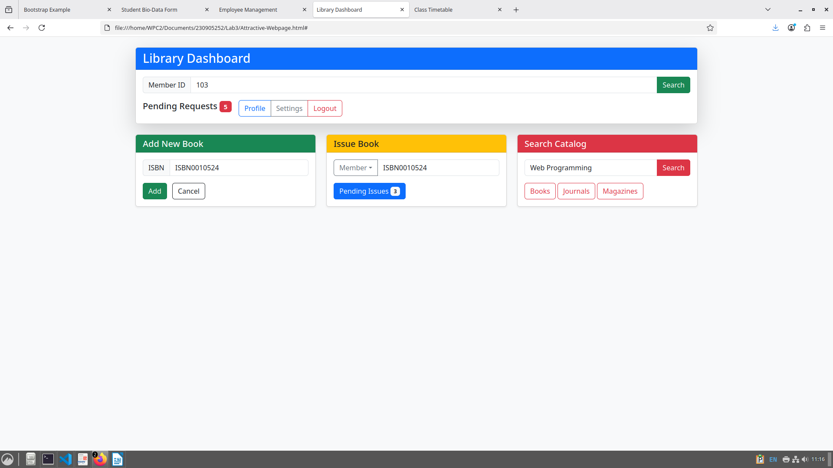

4. Design your class timetable using bootstrap table and carousel.

Code:
<!DOCTYPE html>
<html lang="en">
<head>
<title>Class Timetable</title>
<meta charset="utf-8">
<meta name="viewport" content="width=device-width, initial-scale=1">
<link href="https://cdn.jsdelivr.net/npm/bootstrap/dist/css/bootstrap.min.css" rel="stylesheet">
<script src="https://cdn.jsdelivr.net/npm/bootstrap/dist/js/bootstrap.bundle.min.js"></script>
<style>
td, th { text-align: center; vertical-align: middle; }
</style>
</head>
<body class="bg-light">

<div class="container mt-4">
<h2 class="text-center mb-4">Weekly Class Timetable</h2>

<div class="card shadow-lg mb-5">
<div class="card-header bg-primary text-white">
<h4 class="mb-0">Full Week Grid</h4>
</div>
<div class="card-body table-responsive">
<table class="table table-bordered table-hover">
<thead class="table-dark">
<tr>
<th>Day</th>
<th>08:00–09:00</th>
<th>09:00–10:00</th>
<th>10:00–10:30</th>
<th>10:30–11:30</th>
<th>11:30–12:30</th>
<th>12:30–13:00</th>
<th>13:00–14:00</th>
<th>14:00–15:00</th>
<th>15:00–15:30</th>
<th>15:30–16:30</th>
</tr>
</thead>
<tbody>
<tr><td>Monday</td><td>PE-1</td><td>PCAP</td><td></td><td>CD</td><td>OE</td><td></td><td></td><td></td><td></td><td></td></tr>
<tr><td>Tuesday</td><td></td><td colspan="3">CD Lab (C1)</td><td></td><td></td><td>PE-2</td><td>EEFM</td><td></td><td></td></tr>
<tr><td>Wednesday</td><td>PE-2</td><td>EEFM</td><td></td><td>PE-1</td><td>PCAP</td><td></td><td></td><td colspan="3">WP Lab (C1)</td></tr>
<tr><td>Thursday</td><td></td><td colspan="3">PP Lab (C2)</td><td></td><td></td><td>CD</td><td>OE</td><td></td><td></td></tr>
<tr><td>Friday</td><td>CD</td><td>OE</td><td></td><td>PE-2</td><td>EEFM</td><td></td><td></td><td colspan="3">PP Lab (C1) + CD Lab (C2)</td></tr>
<tr><td>Saturday</td><td></td><td colspan="3">WP Lab (C2)</td><td></td><td></td><td>PE-1</td><td>PCAP</td><td></td><td></td></tr>
</tbody>
</table>
</div>
</div>

<div class="card shadow-lg">
<div class="card-header bg-success text-white">
<h4 class="mb-0">Daily View</h4>
</div>
<div class="card-body">
<div id="timetableCarousel" class="carousel slide" data-bs-ride="carousel">
<div class="carousel-inner">
<div class="carousel-item active">
<h5 class="text-primary">Monday</h5>
<ul class="list-group">
<li class="list-group-item">08:00–09:00 → PE-1</li>
<li class="list-group-item">09:00–10:00 → PCAP</li>
<li class="list-group-item">10:30–11:30 → CD</li>
<li class="list-group-item">11:30–12:30 → OE</li>
</ul>
</div>
<div class="carousel-item">
<h5 class="text-primary">Tuesday</h5>
<ul class="list-group">
<li class="list-group-item">09:00–11:30 → CD Lab (C1)</li>
<li class="list-group-item">13:00–14:00 → PE-2</li>
<li class="list-group-item">14:00–15:00 → EEFM</li>
</ul>
</div>
<div class="carousel-item">
<h5 class="text-primary">Wednesday</h5>
<ul class="list-group">
<li class="list-group-item">08:00–09:00 → PE-2</li>
<li class="list-group-item">09:00–10:00 → EEFM</li>
<li class="list-group-item">10:30–11:30 → PE-1</li>
<li class="list-group-item">11:30–12:30 → PCAP</li>
<li class="list-group-item">14:00–17:00 → WP Lab (C1)</li>
</ul>
</div>
<div class="carousel-item">
<h5 class="text-primary">Thursday</h5>
<ul class="list-group">
<li class="list-group-item">09:00–11:30 → PP Lab (C2)</li>
<li class="list-group-item">13:00–14:00 → CD</li>
<li class="list-group-item">14:00–15:00 → OE</li>
</ul>
</div>
<div class="carousel-item">
<h5 class="text-primary">Friday</h5>
<ul class="list-group">
<li class="list-group-item">08:00–09:00 → CD</li>
<li class="list-group-item">09:00–10:00 → OE</li>
<li class="list-group-item">10:30–11:30 → PE-2</li>
<li class="list-group-item">11:30–12:30 → EEFM</li>
<li class="list-group-item">14:00–16:30 → PP Lab (C1) + CD Lab (C2)</li>
</ul>
</div>
<div class="carousel-item">
<h5 class="text-primary">Saturday</h5>
<ul class="list-group">
<li class="list-group-item">08:30–11:30 → WP Lab (C2)</li>
<li class="list-group-item">13:00–14:00 → PE-1</li>
<li class="list-group-item">14:00–15:00 → PCAP</li>
</ul>
</div>
</div>
<button class="carousel-control-prev" type="button" data-bs-target="#timetableCarousel" data-bs-slide="prev">
<span class="carousel-control-prev-icon"></span>
</button>
<button class="carousel-control-next" type="button" data-bs-target="#timetableCarousel" data-bs-slide="next">
<span class="carousel-control-next-icon"></span>
</button>
</div>
</div>
</div>
</div>

</body>
</html>

Output:

